NVRs (Network Video Recorders) are devices to record videos from your security cameras. Unlike cloud storage, they do not cost you a monthly fee and can be configured for advanced motion control. We looked at what is NVR, its main components and factors to consider in order to buy the best Network Video Recorder. We also reviewed and tested the available options on the market to tell you what best security camera NVR you should buy depending your circumstances and use.
When selecting NVR security systems, we looked into nine main factors to select the NVRs and Amcrest NV2108E is the best network video recorder overall. We also give you two alternative picks for best camera NVRs. Hikvision DS-7608NI which is slightly more expensive NVR, but has some extra functionality like 2 HDDs. GW Security 8 Channel NVR is a beast of a machine and would work if you need advance motion detection or to connect to your alarm system. While we focused on 8 channel model, we also giving you the reasons why we selected Reolink RLN16-410 as the best 16 channel NVR or Amcrest NV2104E as the best 4 channel NVR around.
Contents [hide]
- What is NVR?
  - NVR Hardware
  - NVR Software
  - NVR or Cloud?
- 7 Important Factors When Buying Best NVR Security System
- Top pick for Best NVR: Amcrest NV2108E
  - Vs Competition
- Alternative pick for the best camera NRV: Hikvision DS-7608NI-E2/8P
- Best High-end 8 Channel NVR: GW Security 8 Channel NVR
- Best 16 Channel Security Camera NVR: Reolink RLN16-410
- Best 4 Channel NVR: Amcrest NV2104E

What is NVR?
Buying smart cameras alone might be enough for watching live video streams and getting notifications. But if you want to get more from your cameras you should use cloud or NVRs to record and store videos so you have not missed a thing in your house or office. Benefits of NVRs are not only ability to keep weeks and months of history for free, but also advanced motion detection and other flexible functionality.

NVR Hardware
In NVR comes in a shape of (usually) a black color device with controls in front and ports at the rear. Main ports in the rear are:
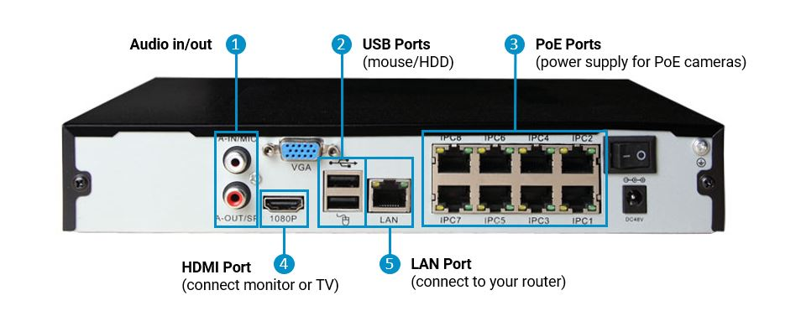
- Audio in/out: to have audio feed in and output to speakers
- USB ports: to connect mouse or HDD (for backup)
- PoE ports: to connect to cameras and provide with the power supply (more on PoE cameras)
- HDM Port: to connect a monitor or external TV
- LAN Port: to connect NVR to your router
Inside NVR would have slots for hard drives for storage of data.

NVR Software
The software interface helps to configure NVR for the first use, maintain the system and also access the video stream live or historical recordings. To do so Network Video Recorders come with built-in software (which you can use by connecting a monitor to the device), desktop client and mobile application.

NVR or Cloud?
Unsurprisingly, NVRs might not work with some smart security cameras like Nest or Arlo as those companies are keen to charge you for cloud storage and they lock down the products to prevent local recording. While having one or two cameras with cloud plan might be a good idea for smaller flats or houses, it will not work for larger setups. Also, if you are like us and not keen to hand over your data to companies that do not have a great privacy protection history buying camera NVR is your best option.

7 Important Factors When Buying Best NVR Security System
In addition to testing network video recorders, we research the manufacturers’ sites, professional forums and reviews on Amazon to understand what is important for customers. Based on that we narrowed down to 7 key factors:
- Number of channels: The more channels (the maximum number of cameras you can simultaneously connect and record) NRV has, the more expensive it will be. To illustrate how it works, if your 8 Channel Network Video Recorder has 8 PoE ports but you already connected 3 wifi cameras, it would only be able to handle 5 additional cameras. Our recommendation is to always buy more channels then you need right now to future-proof your setup. If you have plans for only 4 at the moment, buy 8 channels camera NVR, and if you are planning for 8, it makes sense to buy 16 channels one.
- PoE or not PoE: PoE (Power over Ethernet) allows you to use a single cable for network connection and power supply. This simplifies the setup but require PoE compliant switch, injector or IP camera NVR system to inject electricity into Ethernet cables. PoE ports became a standard for majority of network video recorders now, but you can save money if you definitely do not need them. PoE power supply can vary (for example by the voltage or protocols supported), so check out our guide on the best PoE Cameras.
- Amount of storage: two important storage factors here – (a) how far back do you want to be able to store videos and (b) how secure you want your video feeds to be. The former is dependent on number of cameras, their resolution and whether you want to record constantly, on the schedule or only if there is any movement. Check out Network Video Recorder Storage Calculators to determine how many terabytes you will likely need. As a crude example, for a single 2-megapixel (1080p) camera at 3 frames per second (analog cameras use 1 FPS) and at the highest video quality you will need 16GB of storage for 24 hours of continuous recording. The latter factor refers to what is called redundancy. This is a technical term for having multiple physical copies of the same video streams on different physical HDDs. This would cost you more money but avoids losing all of your history due to corruption (which happens often)
- Advanced motion detection: All modern NVRs are capable of motion detection, but simple algorithms might trigger too many false alarms when used with outside cameras or in crowded areas. Advanced motion detection functionality in the high-end Network Video Recorders we reviewed use line crossing, intrusion and dwell detection methods. Line crossing allows you to add a line or lines crossing which will trigger an alarm. This is ideal for monitoring fences, properties and parking areas that should not be entered. Intrusion detections alerts when somebody enters a certain area (not line). Dwell detection enhances it even more by specifying how long the subject is allowed to stay in the area before triggering the alert
- HD or Super HD: Are you planning to connect your massive TV to NVR and watch all your cameras in your living room? (that is fine, we are not judging) If so, you will need Super HD HDMI output not to lose quality of your cameras on the screen. Super HD usually supports up to 4k resolution. {our high-end pick of the best 8 Channel NVR GW Security 8 Channel NVR would have that functionality)
- External alarm: Some NVRs will be able to connect to the external alarm which can trigger the recording of the video feed. This is a nice feature that can be seen in the top end models, but you will likely be ok with the properly configured motion detection. ( GW Security 8 Channel NVR has 8 inputs from alarms )
- Quality of NVR application: NVRs come with the interface that you can use with the attached monitor and also mobile application. The quality of those application varies across brands and is the additional factor you should look at. We also recommend to use smart hubs to do more intelligent integration of cameras into your home eco-systems.
Other Factors:
- Built-in Wifi: There is a misconception that to use wireless cameras you need to have wifi built-in in your surveillance camera NVR. This is certainly one of the ways, but using your router works just fine. A router would normally have a better signal and more reliable that is why wifi in the network video recorder is not a mandatory function. What is important though, is to have a strong wifi router for your smart home. Consider changing your wifi router if you have a weak signal or still using the stock router from your ISP. {Our top pick for mid-range wifi router is Netgear R7000 or Google Wifi system for full coverage of the big house}
- NRV or NVR bundle: As with many other devices you can save money by buying IP NVRs in a bundle with cameras or just on its own. The bundle would usually be 5-10% cheaper and easier to set up as they come with comprehensive instructions on the installation process which good for less experienced users. This obviously would not work if you already have a number of cameras installed. [Our pick for the best NVR security system with 4 bullet cameras by Amcrest]

Top pick for Best NVR: Amcrest NV2108E
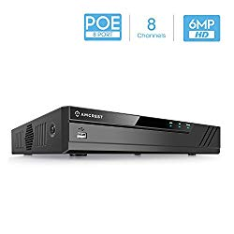
$160 from Amazon
We are in love with the PoE Amcrest cameras (see our top picks for the best PoE cameras) and Amcrest did a great job with NVR as well. Amcrest NV2108E is an 8-Channel NVR capable of supporting up to 6TB of hard drives. HDD is not included and you need to buy it (out top pick is WD Blue 4TB disk for its reliability)
It comes with black NVR with standard ports and controls, USB mouse, Cat5E cable and power supply. For initial setup, you will need a monitor or TV with VGA/HDMI port.

Reasons to buy
- Great value for money
- Easy to setup
- Good quality desktop and mobile apps
- Plug and play detection – cameras pop up immediately
- ONVIF compliant to connect with other models

Be mindful of
- Requires Ethernet connection. There is no built-in WiFi
- Streaming works only with Internet Explorer (like for many similar devices)
- Can playback only 4 cameras
- The network port can only support 10/100mb speeds
- The USB port can be connected to external hard drive but it’s only used for backup configurations/settings/ existing recordings.
Installation and Use
As we mentioned you will need VGA/HDMI cable and TV/ Monitor for setup. To start to connect the network cable, the power cable, and monitor. After booting up, NV4108 asks setup new user and walks through the initial settings such as reset password, set IP and time. Then you will setup existing IP cameras where most of ONVIF cameras (Amcrest or Foscam) will appear automatically. To control Network Video Recorder you can use the buttons on the device or the included mouse.

Vs Competition
- There is some significant functionality missing from the device (like external alarm, or gigabit ethernet. This is standard for the price range and that functionality is not needed for the majority of the users
- Consider out top high-end surveillance camera GW Security 8 Channel NVR if you need any of the advanced features.
- If you do not need PoE ports, consider Amcrest NV2108 ($79), which is an identical Network Video Recorder in the rest of the functions.
- If you planning to playback more cameras simultaneously (and tell us why please) and do not need PoE, you can go for Amcrest NV4108-HS ($99)

Alternative pick for the best camera NRV: Hikvision DS-7608NI-E2/8P
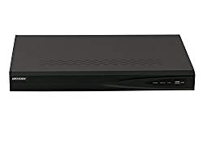
$200 from Amazon
Our alternative pick is 8 channel video by Hikvision. Hikvision has outstanding quality of cameras and this network video recorder continues the trend. The device supports H.264+ and H.264 formats what reduce the sizes video files, synchronous HDMI and VGA Output at high resolution and recording up to 6 Megapixel Resolution at 80 Mbps incoming bandwidth
It is slightly more expensive then Amcrest but has additional features that worth to pay for.

Reasons to buy
- Up to 2 SATA Interfaces which can accommodate extra storage or extra redundancy to avoid risking data loss
- Great support from Hikvision USA
- Good PC and Mobile applications

Be mindful of
- No external alarm connections
- No Super HD HDMI

Best High-end 8 Channel NVR: GW Security 8 Channel NVR
$360 from Amazon
Our alternative pick is 8 channel video by Hikvision. Hikvision has outstanding quality of cameras and this network video recorder continues the trend. The device supports H.264+ and H.264 formats what reduce the sizes video files, synchronous HDMI and VGA Output at high resolution and recording up to 6 Megapixel Resolution at 80 Mbps incoming bandwidth
It is slightly more expensive then Amcrest but has additional features that worth to pay for.

Reasons to buy
- Recoding of 8MP per camera
- Support of up to 16TB HDD
- 8 alarm input, 1 alarm output
- 3 USB3.0 ports
- Advanced controls and motion detection that other brands do not have
- Easy to setup

Be mindful of
- Documentation is subpar in some cases so you might revert to online forums
- PC Remote access through internet explorer only
- Loud fan

Best 16 Channel Security Camera NVR: Reolink RLN16-410
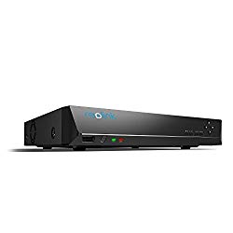
$330 from Amazon
Our top pick is RLN16-410 by Reolink. Reolink became a go-to brand for home video surveillance thanks to the great and consistent quality of the products and superb customer support. RLN16-410 is a 16 channel IP Camera Network Video Recorder with 16 PoE ports and capable of recording up to 4MP camera feeds. NVR can playback 4channels video at 120fps. It comes with all the standard functions like HDMI streaming (not 4k), motion detection (not advance) and good quality applications for both PC and mobile (Android and iPhone).

Reasons to buy
- Great value for money
- Can attach external HDD through eSATA port
- Easy to setup
- Good quality desktop and mobile app

Be mindful of
- Noisy Fan, which might be an issue for quite rooms. You can replace it with the alternative fan (like Noctua NF-A4x10 FLX) under 3 minutes
- Browser Streaming only in IE
- Built-in HDMI interface is a bit slow and chunky

Best 4 Channel NVR: Amcrest NV2104E
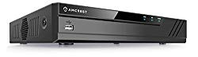
$160 from Amazon
This was an easy choice. Amcrest device provides one of the best balances of quality and price. Similar to our 8-channel choice this surveillance camera NVR supports 4 camera feeds and has 8 PoE ports to connect to PoE cameras. It has the same benefits and weaknesses as Amcrest NV2108E, but we recommending to spend just a little more and get 8 channel NVR if you ever planning to grow your IP camera population.

Reasons to buy
- Great value for money and easy to setup
- Plug and play detection
- ONVIF compliant to connect with other models

Be mindful of
- Can playback only 2 cameras simultaneously
- The USB port can be connected to external hard drive but it’s only used for backup configurations/settings/existing recordings
- Not significanly cheaper then 8 channel version

Surveillance cameras are must-have security devices for your smart home. Using Power over Ethernet (PoE) to power your cameras not only simplifies the installation process but makes your cameras more secure and easier to manage. We tested and researched all the main options in the market to give you a recommendation on the best PoE cameras available.
The article also reviews PoE basics to understand main factors you need to consider when selecting best PoE smart IP cameras. Based on that, we provide the best product for each budget category under $70, Mid-range up to $150 and high-end PoE surveillance cameras over $150
In this review we are mainly focusing on bullet cameras as the most relevant option for the wired installation. Dome security cameras might be a better solution in some cases so we also outline our top picks. Note that in our opinion it makes sense to pay extra money for dome or turret surveillance IP cameras only if you have somebody looking at the feed and moving the camera position
Contents [hide]
- What is PoE?
  - PoE Benefits
  - PoE Drawbacks
  - What do you need for PoE
- Best PoE Camera under $70: Amcrest HDSeries IPM-743E
  - Main Features
- Best PoE Camera up to $150: Phylink PLC-335PW
- Best PoE Surveillance Camera over $150: Reolink RLC-423

What is PoE?
PoE works by combining power supply and network connection into one Cat5/Cat5e/Cat6 cable. PoE can be used to power a number of devices including security IP cameras, access points and even Voice over IP phones. To inject electricity into Ethernet cable you need to use one of the PoE compliant devices either PoE injection that you use on top of your Ethernet cable or have a PoE compliant router that already injects power into the cable.
From a technical perspective, you need to be aware of two main specifications. PoE (or 802.3af) works with a maximum of 15.4 Watt per each port. PoE+ (or 802.3at) on the other hand goes up to 25.5W. The majority of PoE surveillance IP cameras will use well under 15.4 Watt so PoE is enough. The only exception is PTZ (pan-tilt-zoom) security IP cameras which require more power to move the lenses around. You can learn more in our guide to PoE Power Supply Devices

PoE Benefits
- More cost effective for larger networks
- Simple cabling which reduces the installation cost
- Easy maintenance (power functions like switch on and off available)

PoE Drawbacks
There are not many. One that comes to mind is if you go PoE route there will be another device to a house somewhere and look after. Also in the unlikely case of the PoE power supply failure, you will lose all your cameras while a separate power supply per camera would potentially be more resilient.

What do you need for PoE
As we mentioned, you can inject the PoE into your cable using three PoE power supply devices
- PoE injector – a small device for one or two devices. Our top pick is single Gigabit port injector by TP-link
- PoE switch – provide a power source for multiple PoE consumers. Our top pick is 4 port switch by Netgear
- PoE NRV – can power and record your IP surveillance cameras. Our top pick is 8 channel NVR by Amcrest
You can get more details in our practical guide on how to choose best PoE Injectors, PoE Switches

Best PoE Camera under $70: Amcrest HDSeries IPM-743E
Cameras in this category are solid working machines but generally have lower resolution. This will be fine if you are installing to cover smaller indoor areas or do not require to monitor fine details.
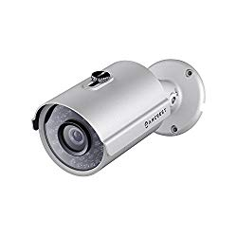
Check reviews on Amazon
Our top pick is Amcrest HDSeries IPM-743E. It is a small-bodied 1.3 Megapixel 960p surveillance camera that works both for indoor and outdoor installation. They are easy to setup, very reliable, and provide good quality of the picture. ONVIF compliance means that you can connect to the devices of other brands such as network recording devices or phone applications with no complications
Vs Competition
- Amcrest is a solid camera and if you accept the limitation of the resolution and plan to use it for a smaller area to cover, there is no reason to buy any other option. It also has one of the best prices for this segment
- If you pay just a little bit more, you can also have a look at Reolink RLC-410 which has higher resolution and wider angle

Main Features
- Definition of 1.3 Megapixel 960P Video at 30fps.
- Amcrest Cloud Video Recording Service Available.
- Quick PoE setup using iPhone or Android application
- Wide 71-degree angle lenses with digital zoom, and IR Night Vision

Reasons to buy
- Best value for money
- Great customer support
- Good iPhone and Android applications
- ONVIF compliance

Be mindful of
- Live view only works with the Internet Explorer
- Instructions might be improved
- Oversensitive night mode
- Small viewing angle
Installation and Use
The camera comes with the standard kit and includes a camera itself with the power supply cable for PoE as well as the conventional power supply jack. There are also you have a weather sealed cable and a connection sleeve. It was noted that you won’t be able to thread existing plug through the connector and either cut the plug and install the connector again or buy another connector.
Installation is quick if you already sorted PoE cables. Plug in PoE cable into the camera and use your phone or PC for the initial setup. Amcrest provides a very good “Amcrest IP configure” application which we recommend to use for configuration. Do not forget to immediately change the initial password
Next, you will need to configure camera monitoring parameters. Make sure to set up the motion detection areas, notifications and specify the recording mode. We recommend using SD card slot as the secondary recording option.
Using camera is usually more light touch than configuring it. Depending on the preferred way to access your camera you just need to make sure that you configure your phone, NVR or PC accordingly.
Armrest Cloud is a good option to never lose the video feed, but it will cost you some money. The current price minimal plan for seven days of recording is $6 per month per camera which includes the unlimited streaming.

Best PoE Camera up to $150: Phylink PLC-335PW
Mid-range PoE cameras have a better video resolution so can be installed to cover larger indoor or outdoor areas. They will be able to provide you with fine details and help law enforcement agencies to identify criminals if required.
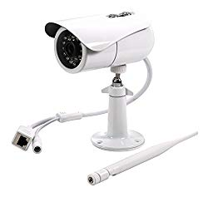
Check reviews on Amazon
Our top pick is Phylink PLC-335PW. Phylink is a relatively new hardware brand that is gaining popularity due to the solid quality of the products and great customer service. Phylink PLC-335PW is part of the family of PoE cameras under each price segment with outstanding video quality and well-thought design.
Main Features
- 1080p high resolution with night vision of 30ft
- 60 Degree viewing angle
- Can also connect using wifi
- IP66 weatherproof rating and comes with a waterproof junction box
- Comes with microSD slot

Vs Competition
- The most notable competitor is by another new brand Reolink. RLC-411S has higher resolution but comes without wifi or SD card

Reasons to buy
- Well build and reliable camera
- Extremely responsive support team
- Great for outdoor installation

Be mindful of
- Stock PC software is slow
- Setting up the camera requires you to go online
- Phylnik is mainly hardware company so you will not be able to find cloud or accessories
Installation and Use
Hardware installation is similar to the process we explained above for Amcrest camera. You will need to ensure that Ethernet cable (and PoE power supply) is provided first. Use the junction box to make sure that the connection is weather protected.
Next step is to install the mount for the camera – you need securely attach the mount to a wall or ceiling. The last step is to adjust the positioning and the sunshade as required.
Software installation is also straightforward. You can do it by using applications on iPhone or Android or by using the Phylink camera live PC installation application. Wifi connection can be configured using the same applications, or you can use WPS on your router.

Best PoE Surveillance Camera over $150: Reolink RLC-423
We struggled to justify the bullet camera with the over $175 price tag taking into consideration two options from mid-range above (Reolink RLC-411S and Phylink PLC-335PW). The only viable options in our opinion that worth extra money is PTZ (pan-tilt-zoom) cameras.
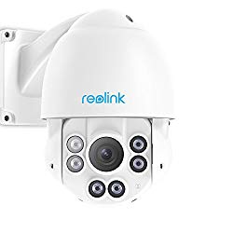
Check reviews on Amazon
PoE PTZ cameras offer much more flexibility in covering larger areas and also offer one of the most useful functions called “cruise path”. Reolink RLC-423 is a high-quality camera with the outstanding build quality and reasonable price for functionality provided. Cruise Path is something everyone should use. It lets you set multiple locations for the camera to look
Main Features
- 5MP 3072*1728 Super HD resolution with long range IR
- Pan-tilt-zoom has endless 360˚ pan & 90˚ tilt & 4x optical zoom leaving no blind spots

Home Assistant, one of the best open source smart home hubs, can integrate devices from almost any brand across many protocols. The abundance of the choice is, however, makes it difficult to find the best one for your needs. This article gives a simple direction of the best products across the main smart home categories that will not only be a practical choice but also work well with the Home Assistant.
This list might be useful for you even if you do not have Home Assistant. Our recommended devices are not only the best in the respective categories but also have a great price.
All recommended options below were tested to work with Home Assitant and also received praise from both Home Assitant community and smart home enthusiasts. Please leave a comment below if you have any other recommendation to share.
Contents [hide]
- Server: Raspberry Pi 3b+ ($79)
- Comms
  - Zwave/Zigbee stick: HUSBZB-1 ($47)
  - Zwave Stick: Aeotec-Z-Stick-Z-Wave ($45)
  - RF/IR hub: Broadlink RM Pro ($39)
- Sensors
  - Multisensor: Aeotec Multisensor 6 ($58)
  - RF motion sensor: Sonoff RF Motion Sensor ($12)
  - Door/Windows sensor: Ecolink ($37)
  - Water Leak Sensor: Dome ($35)
- Light Control
  - Switch: Innovelli ($35) / Sonoff ($25)
  - Smart Bulb: Color - Tp-link ($27) / White - GoControl ($21)
- Security Cameras
  - Security Camera: Wyze ($37) / Amcrest ($90)

Best Server for Home Assistant: Raspberry Pi 3b+
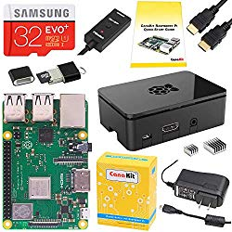
$79 from Amazon
To start using Home Assistant to make your home smart you need a server. A server is a computer that is constantly running Home Assistant application and connects all your smart devices to a single hub.
The best option when choosing a server for Home Assistant is Raspberry Pi. It is a small factor, powerful but cheap mini-computer. The main advantage of using it is having a dedicated computer meaning a minimum impact on the other systems if Home Assistant breaks.
With New 3B+ Raspberry Pi a significantly more computing power is available at the same price. This in addition enables you to run other services like CCTV server Shinobi and maybe even PlexTV for your media. Home Assistant developers also recently developed a dedicated operating system (HassOs) which has improved the capability of the system.
The installation process is simple, with the only complication can arise when setting a wifi password or a static IP for your server. It explained well in the installation guide so please make sure you follow each step carefully.
Alternative Servers for Home Assistant:
- Another option for Home Assistant server is to use NAS. NAS is the network attached storage devices with the primary purpose to store your files in your own hardware, not in the cloud. NAS servers usually have fairly good CPU and you can save money by also hosting Home Assistant. Our recommendation for NAS to use with Home Assistant is Synology 4 bay NAS DiskStation DS918+ This is due to a number reasons, but mainly because of the practicality of the Synology products, value for money and ease of installation. Setting up NAS with HA is a more difficult affair than on Raspberry Pi. You can use the official guide to make sure you do everything right.
- For more flexibility and customization, you can run Home Assistant in your own home server. The difference to NAS is that the home server is usually powerful and can be used for a variety of services. As an example, you can use it not only for the storage but to run media servers, VPNs and many other applications. The disadvantage is that the installation and maintenance of the server usually require unix skills and more complicated than maintaining Raspberry Pi or a NAS platform. One of the proved and good starter home servers is Microserver Gen 8 by HP. It is complemented by many for its low price, expandability and variety options of operating systems you can have. Installing Home Assistant on the home server is dependent on host OS (Ubuntu, CentOS, ESXi, Proxmox). You will need to use official guides for your specific circumstances.

Best comms stick for Home Assistant: HUSBZB-1
The true potential of Home Assistant is in integration with almost any smart home device but to do so you need to create a single smart home ecosystem. Ideally, you want to have a local connection to your devices and not be dependent on the internet. This will also improve the security and resilience of your smart home
Local connections (except wifi and Bluetooth) will require some additional investment in extension sticks for your servers.
Home Assistant can work with almost any protocol (Zwave, Zigbee, RF, Wifi, Bluetooth) but will require connecting a comms stick to your server
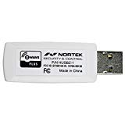
$47 from Amazon
Zwave is arguably the most popular communication protocol to control devices, especially for sensors and lights. Comparing to ZigBee, another popular protocol, is a more homogeneous and standardized protocol. At the same time on average the Zwave devices are more expensive. Using thousands of Zwave devices with Home Assistant is easy and it can be done via sticks that you can plug into your server and control using built-in Zwave control panel.
Zigbee is a similar protocol but with a more restricted architecture. Many brands like Hue, Ikea Tradfri and Xiaomi use it in their devices. The main advantage of using Zigbee is the price as the devices are generally cheaper comparing to Zwave. At the same time, producers use Zigbee to lock consumers within their eco-systems. The recommended stick can solve this problem.
HUSBZB-1 stick is a unique product as it provides a connection to both Z-Wave Zigbee networks. It can be plugged into a USB port and work with major home automation platforms. This will mean you can stop using perpetuity hubs like Philip Hue Bridge or Ikea Tradfri hub
Once installed, the stick appears as two (2) serial ports but a number of community posts like this or this will explain how to set it up.
Working with Z-wave is very simple as the pairing done pressing the button on both the stick and device. The same process is trickier for Zigbee devices as you will need to run it like a service not hardware driven process (like for zwave). To start it go to developer tools –> Services and type zha.permit and press Call Services. After that, you will be ready to connect your ZigBee devices.
zwave:
usb_path: /dev/ttyUSB0
zha:
usb_path: /dev/ttyUSB1
database_path: /config/zigbee.db

Best Zwave stick for Home Assistant: Aeotec-Z-Stick-Z-Wave
If you are planning to have only Zwave devices, Aeon Zwave Stick is the best option for comms stick. Aeon is a very solid brand consistently producing great quality smart home devices including sensors/lights controls and Gen5 stick is not an exception. It is a well-priced device that gone through a number of iterations and trusted by many Home Assistant users
It is a small device similar in size to usb stick and 1.1 x 0.4 x 3.5 inches in size and capable of controlling up to 232 different Z-Wave devices. It is also Z-Wave Plus certified.
Installation is easy – just plug it into your server and add a couple of lines of code into your configuration.yaml. Paring with the devices is done through the button on the device which has a battery so you can bring it closer to the device if needed. From there on paired devices will appear in home assistant and you can configure them using Zwave control panel.
You can also consider the following alternative options:
- Z-WAVE.ME ZMEEUZB1 is a good option, but reliability and quality of Aeon is worth paying extra
- Z-Wave.Me RaZberry is an addon to Raspberry Pi and generally received good reviews, but a similar price Aeon stick can also work with home servers and even Windows computers

Best RF Hub and Best IR hub for Home Assistant: Broadlink RM Pro
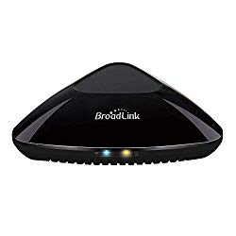
$39 from Amazon
To have the most comprehensive system, we also recommend integrating RF and IR protocols to Home Assistant. RF (Radio frequency) is not a very sophisticated protocol (the most used frequency is 433Mz). RF protocol operates with simple one-way signals that can be interpreted as “the door is open” or “switch on TV”. One way signal means that RF devices will not confirm that the signal was received and/or task performed. That limited functionality is balanced with the price which is usually from two to five time cheaper than ZigBee or Zwave.
IR (Infra-red) is the most common protocol for the majority of TV, Projector or air conditioner remotes. This can help you to make smart otherwise “dumb” devices in a very practical way. As an example, I have a projector and a ceiling screen and by single command, Home Assistant switches on a projector via IR, send the RF signal to lower the screen.
Broadlink RM Pro is the best option to add IR and RF to your Home Assistant. Broadlink products consistently offer great quality at a reasonable price and this is the third generation of devices bringing further functionality improvements. Also, Broadlink RM Pro has its own component in Home Assistant, meaning it is really easy to add the device to your system.
Setting up the IR or RF devices is equally easy. The included app allows you to identify the messages that you need to send to your devices and configure the switches in Home Assistant. See a couple of examples of such integrations in this guide.
If you only need RF for your devices, Sonoff RF bridge might be a better solution. It is twice cheaper comparing to Broadlink but will need some tinkering to integrate with Home Assistant and add the devices. Nonetheless, it offers a great value for money.

Best Sensors for Home Assistant
Sensors are the next crucial elements of any Home Assistant setup. They allow you to use environment awareness for automation triggers or conditions. As an example, motion, the amount of light in your room, its temperature or detection of water can start or be a condition of automation rules. That is sensors that ultimately can bring true “automation” so you do not need to manually switch on lights and so on.
There are many hundreds of smart sensors and below is the selection of the most practical ones across the main categories that you can buy. To connect sensors, you just need to pair it with the hubs or sticks recommended above. Z-wave devices will automatically appear in your system, while for Zigbee, RF or Wifi sensors you likely need to include couple of lines in the configuration files. Once done, you can use states (like open and closed) or other attributes like luminance or battery levels in your automation rules.
Please note that one sensor (especially multisensory) can be shown as multiple sensors. Also, you will see the binary sensor and sensors where the binary sensors will only have two states (usually “on” or “off”) .

Best Multisensor for Home Assistant: Aeotec Multisensor 6
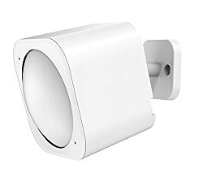
$58 from Amazon
Multisensors combine motion, temperature, humidity, luminance and burglar sensors into one device. If placed in the right location you can not only enable smart routines but also save money by not buying two or more sensors.
Aeotec Multisensor 6 is the best overall multisensor. We like its quality, ability to be powered by USB and fine tuning (for example sensitivity levels and updates frequency for battery). It combines motion, temperature, humidity, and luminance to empower the most intelligent automation rules. It can also be installed using ceiling recessor.
As the alternative Dome sensor would be a good option for motion and light sensors only (which is all you need for light control). It has a slightly better price and comes with the magnetic base for better positioning.

Best RF motion sensor for Home Assistant: Sonoff RF Motion Sensor
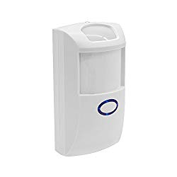
$12 from Amazon
RF-based sensors are two to five times cheaper than the ones based on Zwave or Zigbee. Low price comes with some compromises and comparing to Z-wave multisensors those devices might be less reliable and precise. However, for some applications (like motion detection) that is all you need and can be a practical option
RF sensor from Sonoff is one of the best indoor motion sensors. Our recommendation is based on known quality and value for money of Sonoff devices and also the improved functionality of the motion sensors. Dual infrared improves the sensitivity and using ultra-low power microprocessors means that you do not need to change the batteries too often. Double temperature compensation technology avoids too many false alarms. All the this with really easy installation and set-up make it a simple choice. One thing you need to remember is to have RF hub like Broadlink RM Pro we recommended above.
For best outdoor RF motion sensor for Home Assistant, we recommend JC RF Motion Sensor. It offers pretty much the same functionality as Sonoff with the only exception of being waterproof and suitable for outdoor installation.

Best Door/Windows sensor: Door and Window Sensor by EcoLink
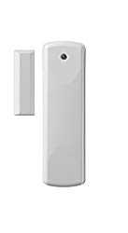
$37 from Amazon
Door or open/close sensors (also called windows sensors) report two main states: open or closed. There are many uses, but the main is to report the statuses of entry points to your home (doors or windows). You can also monitor when you got any mail, switch on the lights for your wardrobe and so on.
For this type of sensors (especially if used for security purposes), we recommend Zwave for reliability. Door and Window Sensor by EcoLink if your best choice for reliability, ease of installation and a reasonable price. As a bonus, it can work with additional wired sensors near the device.
Best Water Leak Sensor for Home Assistant: Dome Home Automation Leak Sensor
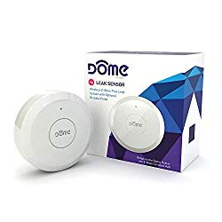
$35 from Amazon
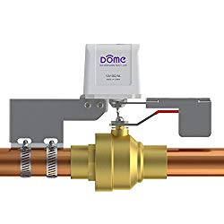
$99 from Amazon
Leak sensors save you money preventing damages from pipe burst pipes. Over 5 million people a year experience flooding in the US due to pipe burst with average damage ranges being between $3,500 down to $25,000. This can easily be avoided with the leak detectors and water shut off valves.
To guard against such risks, leak detectors should be installed in the areas at the risk of being flooded. This includes washing machine, dishwasher, and sinks in bathrooms and kitchen. They can be powered through mains or internal batteries that last a long time.
After testing a dozen options in the market Dome Home Automation Leak Sensor is not only the best-looking sensor around but also a reliable z-wave device that can be used together with the external water probes and (not very loud) internal alarm. Integrating Water leak sensor is simple as it is just another zwave devices that will appear in Home Assistant once paired to z-wave hub or stick.
Leak sensor is great as it will notify you that you have a problem, but you need a device to shut off your mains water to prevent any damages. That is where Dome Home Automation Water Shut-Off Valve offers good response times and simple installation. There are other alternatives like Guardian by Elexa ($399) and Automatic Shut-Off Valve by leakSMART ($229), but with the price at least twice more, neither have any local (i.e. zwave of wifi) connectivity and even looking more robust do not offer significantly different functionality.

Light Control for Home Assistant
Lightning is the easiest thing to automate once you have your server, comms, and sensors. We use them every day and as the use is usually based on very simple rules (only on when somebody in the room and it is dark outside) – the automation is straightforward.
You will need two elements – a sensor to help Home Assistant decided when to switch on or off the lights. Ideally, you want to combine it with luminance sensor so lights will be on only at motion when it is dark in your room. (see above our recommendation for Aeon Multisensor ($58)
The active element is a device that will actually switch the lights on and off. You can do that by buying a replacement for your bulbs (or LED) or the smart switch. The latter is a preferred option as it will save you money in the long run (as you can use normal bulbs which are cheaper). The other advantage is that you can physically control your lights. On the other side, you cannot control the brightness or color of lightning.
Integration of lights and switches to Home Assistant is dependent on the device used. With zwave it is a simple process of pairing to stick or a hub. For wifi and/or mqtt devices you will need a bit more effort and potentially couple additional lines of code in your configuration files.
Switches and lights can be controlled in Home Assistant using actions of lights or switch components. Two basic ones are turn_on and turn_off actions. You can send additional parameters like brightness or color with turn_on action if it is supported.
Best switch for Home Assistant:
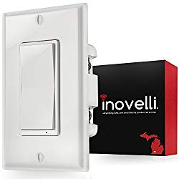
$35 from Amazon
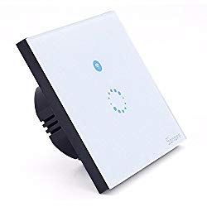
$25 from Amazon
Note that with the noted advantages over bulbs, smart switches require a neutral wire in your switch box to be installed.
Our tests and feedback from Home Assistant Community show that Innovelli Z-Wave Switch (On/Off) is the best zwave switch for Home Assistant. It is Z-Wave Plus devices which can do scene control, acts as the repeater and can brew you a perfect cup of coffee. Kidding of course, but the device is a simple, elegant but easy to use that has a reasonable price. You can also programme it to do different actions based on single or multiple clicks which is a nice functionality.
Alternative and a more practical solution is a Sonoff Smart Switch (which can be 1, 2 or 3 gang). It might not look as beautiful as Innovelli, but has a significantly lower price. To make it work with Home Assistant, you will need to install a custom firmware. It might sound complicated, but you can do it over the wifi within 10 minutes so no soldering required. Please look at SonOTA section the official documentation in the Sonoff-Tasmota git website. This will turn Sonoff into MQTT switch and you will just need to install mqtt broker in your Hass.io and add a couple of lines of code in the configuration file.
Best smart bulb for Home Assistant:
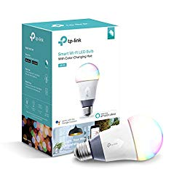
$27 from Amazon
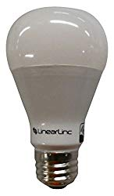
$21 from Amazon
Comparing to switches bulbs give you extra controls. You can adjust to any colour, set the brightness and colour temperature. One thing to be aware with the bulb is to make sure that your family members won’t physically switch off the bulb with the switch.
For colour bulbs, TP-Link Smart Wi-Fi A19 LED is a reliable and bright colour bulb that does not require a hub. Like the majority of the other TP-link smart devices, the bulb has outstanding functionality for the reasonable price. It works out of the box with only a couple of lines to be added to the configuration file (guide). If you do not fiddle with config files, the best way to go is Z-wave bulb and Zipato RGBW2.US Z-Wave might be your best option.
For white only GoControl Z-Wave Dimmable LED Light Bulb is a good 60 Watt Equivalent LED white Dimming Light Bulb that you can just plug and play if you have the necessary

Security Cameras
Cameras is the next important part of your smart home. You can use them for the security purposes, to look after your kids and also to monitor what your cat is up to. Below is the brief summary of the comprehensive guides the details of how to use the camera and what is the best camera for Home Assistant.
Main things you can do with Cameras in Home assistant is
- Notifications: you can send snapshots or video clips if there is any movement or door has been open
- Motion and Luminance sensors: with the right camera you can save some money on buying sensors
- Baby Monitors: you can be notified and can hear via Chromecast or Google Home for example when you baby woke up
- Artificial Intelligence; this is an emerging area, but you can already count faces (and pause your movie if somebody left) or identify intruder using local AI with you Home Assistant
Best Security Cameras for Home Assistant:
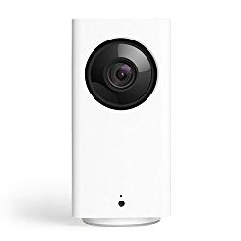
$37 from Amazon
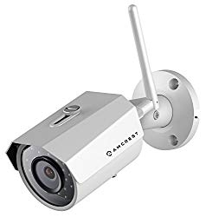
$90 from Amazon
Our pick for the cheapest camera for Home Assistant is Wyze Indoor Camera. This camera is the third iteration with the previous two products also being a success.
Wyze Cam Pan brings full view coverage together with 93-degree vertical tilting with the same great 1080 picture quality and good night/day performance. In addition to the audio and video feed will give you motion tracker and luminance sensors in Home Assistant. Similar to other practical devices, you would need to install a custom firmware. It should not take more than 10 minutes and all you need to do is to use the microSD card to copy the firmware files, modify the configuration to your wifi. After that, the camera will become a full-fledged MQTT camera capable of motion and luminance detection in Home Assistant. For installation, you can follow a simple guide.
For the outdoor camera, we recommend Amcrest 2304TVL which is a solid 3-Megapixel camera with wide 100º viewing angle and waterproof. As many Amcrest cameras, this comes with 4 Hours of Free Cloud Storage. It is very easy to install to cover your porch or your garden and even easier to integrate with Home Assistant. As the bonus, you will be able use motion sensor in Home Assistant potentially saving you some money. Follow additional information in Python Amcrest project or in our guide.

H ome Assistant, one of the best open source smart home platform, has a lot to offer when you integrate IP security cameras. You can use them as motion detectors, send snapshots with notifications and even count faces with local/cloud AI.
Not all cameras would work well with Home Assistant and even fewer are easy to integrate. We tested cameras from allmajor brands and smaller producers to help you to select the best camera for Home Assistant and configure it for your setup.
Wyze Pan Cam ($37) is the most affordable solution but require some integration effort. Amcrest IP3M-943W ($89) is our choice for the best quality and ease of connection camera for Home Assistant. It requires only a couple of lines to be added to your configuration files and outstanding camera on its own. Axis P1435-LE ($596) is the best high-end camera due to the amazing quality of video feed, build but high price. And Blink Indoor Battery Camera ($99) is the recommended option if you want to have battery operated cameras for Home Assitant (it still last over the year in one charge)
Contents [hide]
- What can you do with cameras in Home Assistant?
- How to Select a camera for Home Assistant?
- Different types of security cameras for Home Assistant
- Best camera for Home Assistant: Wyze Indoor Camera
- Alternative Pick: Raspberry Pi Camera + MotionEye
- Easy to setup Home Assistant camera: Amcrest
- Alternative Pick easy to set up camera for Home Assistant: Foscam
- Best battery powered camera for Home Assistant: Blink Indoor Camera
- Final thoughts

What can you do with cameras in Home Assistant?
- Notifications: This is the most fundamental and useful feature of integrating cameras to smart hub. Motion and entrance detection is at the heart of any security system but it is a camera that shows you what triggered the alarm. It will help to avoid false alarms or show that you need to call the police immediately
- Motion Detection: Instead of buying both a motion sensor and a camera, Home Assistant can combine those two functions within your camera. Cool, right? This can save you $30-50 (See our review of best smart sensors). Some cameras would also have a passive motion detection (like Blink) making motion detection with the camera even easier
- Baby Monitors – you can make the camera an intelligent and smart baby monitor. Build-in motion detection can notify you when the baby is waking up. But even a more efficient way is to link the audio feed from the camera to the home assistant as a sensor. You can be notified or even hear what is happening in your kid’s room if the noise is louder than the threshold. (Audio can also be transmitted to your Chromecast or Google Home). See how to implement using this guide. The only requirement is to have a camera that supports separate audio feed locally (like Amcrest IP3M-943W ($89))
- Artificial Intelligence – there are a number of existing uses of the AI with the camera feed. This cool guide is an example of how to set up a routine that can allow the alarm to go on if there is an intrusion in the certain area. Face Counting is another of the intelligent uses of the camera feeds. You can count the number of faces that the camera sees and link to the automation rules. For example, you can pause the movie if someone is leaving for a different room. This can be done by counting the number of faces and triggering an action if it reduced while the movie is on.

How to Select a camera for Home Assistant?
We reviewed 10 main factors to consider when buying a security camera in our practical guide in buying a security camera. Below is a recap of three of them and one additional factors specific to Home Assistant
- Type of camera to buy: Outdoor/Indoor – outdoor cameras are usually a bit more expensive but have better weather and waterproof protection. Form factor – you can choose a bullet / dome / turret / PTZ/ freestanding. Bullet camera would be by default cheaper cost in the same functionality as a simpler device with no moving parts. PTZ is on the other spectrum and can cover big areas, but significantly more expensive
- Resolution: 1080p (2k) is the current standard for the indoor camera. It is enough to cover the medium size area, but if you need to cover large rooms or outdoor spaces, consider going to 4k or even 6k resolution. Another consideration is the storage. Higher resolution would require more storage. Network Video Recorder Storage Calculator helps to determine how many terabytes you will likely need. As a crude example, for a single 2-megapixel (1080p) camera at 3 frames per second (analog cameras use 1 FPS) and at the highest video quality you will need 16GB of storage for 24 hours of continuous recording. You can learn more about NVRs in our guide on the best NVRs for your security cameras
- Wireless or wired: Wireless cameras are easier to install as only require power, but generally considered less reliableю Wired cameras do not depend on the strength of wifi signal and use Ethernet cable to connect to your router. This is more secure option, but wifi cameras significantly improved the reliability. It is also important to make sure you have a good quality powerful router for your smart home. We recommend looking into replacing the stock ISP router with more powerful option like NETGEAR R6700 Nighthawk. For wired cameras, we strongly recommend using PoE to power cameras. Please have a look at our guide on What is PoE and Best PoE injectors
- Integration with Home Assistant: Integration to the camera to Home Assistant is another important factor to consider. It will determine how easy to use the camera in your automations rules and also what camera functionality will be available in Home Assistant.o There are three ways to integrate a camera into Home Assistant:
A. Generic camera means that HA will use http or rstp protocols to connect with cameras. This might require some IT skills, but in principles, you can integrate with almost any generic ONVIF camera and even any other cameras open to local streaming.
B. Native integration. Home Assistant has 36 native camera components. Around 20 of those components are integrations with specific brand cameras like Foscam, Axis, Blink and many others. This means that connecting the camera to Home Assistant would take a couple of lines in your configuration file. However, not all camera components are equal. Internet dependent cameras like Arlo or Netamo would have limited functionality and only work via the internet connection. The others like Axis or Amcrest can be used as sensors and also function perfectly during the internet outage (which we consider a must for security cameras)
C. NVR – Home Assistant also allows to integrate with cameras through Network Video Recorders and NAS. This means that you will need to set up cameras in your NVR and then integrate NVR into Home Assistant. At the moment, you can do that with ZoneMinder (quite dated software NVR) and Synology NAS.

Different types of security cameras for Home Assistant
We reviewed more than 20 cameras and outlined the best product across four categories. All the cameras below can be used locally i.e. even if you will have an internet outage (or somebody tampers with your internet connection) the cameras will still work. The only exception is Blink camera which is a battery-operated camera.
- Best affordable camera for Home Assistant – the cameras under $40 which sometimes require some additional workarounds (or flashing firmware). They usually also have less functionality comparing to other options
- Best mid-range camera – cameras that can be integrated to Home Assistant and offer wide range of functions for automations rules (motion sensors, noise sensors etc)
- Best battery cameras for Home Assistant – wired cameras for extra resilience for your security system

Best camera for Home Assistant: Wyze Indoor Camera
$37 from Amazon
Our pick for the cheapest camera for Home Assistant is Waze Indoor Camera. Wyze is a poster child startup with the honorable mission to make good quality cameras at the affordable price. And boy they are crushing it. This camera is the third iteration with the previous two products also being a success.
Wyze Cam Pan brings 360-degree coverage together with 93-degree vertical tilting with the same great 1080 picture quality and good night/day performance. This device would cost you just slightly over $30 and the best option for the indoor camera to act as child or pet monitor or just a general-purpose security camera. Integration with Home assistant is also really good and in addition to the audio and video feed will give you motion tracker and luminance sensors in Home Assistant.

Reasons to buy
- Good quality 1080 video
- Impressive night vision
- Surprisingly simple and easy to use app
- Great at working with Home Assistant (through custom firmware)

Be mindful of
- Audio quality can be improved

Installation and Use
This freestanding camera is simple to use and install. You will need to download the Wyze app to connect it to the wifi and it is pretty much ready to go. The application itself is very intuitive and friendly which is a stark contrast to the application of the majority of camera producers.
The best part comes when you combine the camera with Home Assistant. With the custom firmware, the camera is capable of using motion and luminance sensors in HA. The custom firmware uses MQTT to communicate which simplifies the integration even more. To install it, you need to follow a simple guide. It should not take more than 10 minutes and all you need to do is to use the microSD card to copy the firmware files, modify the configuration to your wifi. After having custom firmware for the camera, MQTT should be enabled in Home assistant and you will see the new entities for all the camera controls and sensors

Vs Competition
- If you need a camera with a smaller body, you might look into the other camera from Wyze – Wyze Cam. It is slightly cheaper at $25 and the only thing missing is pan and tilt functionality.
- For dome cameras, you might look into Yi Dome ($34). You can install custom firmware similar Wyze following Yi-Hack-v3 guide
- We have not identified a cheap outdoor camera for Home Assistant that we are happy to recommend and that is why we suggest looking into Amcrest IP3M-943W ($89) as a good balance of functionality, weather resistance, and price
- There are a number of similar cameras like Dahua IPC-HFW1320S ($74), but we have not seen a compelling reason to prefer it over Wyze

Alternative Pick: Raspberry Pi Camera + MotionEye
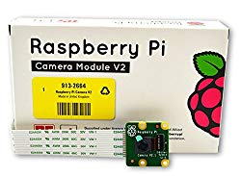
$24 from Amazon
The only additional option we will highlight is Pi Camera with Motioneye OS. If you have raspberry pi lying around (if you like me you probably got a couple of iterations of the Pis) you can invest extra $24 and buy the camera addon. The whole setup up with enclosure, a power supply will not be significantly cheaper but works well if you have unused parts.
MotionEye is a custom build OS, which can be installed under 10 min and have very good UI that enables you to configure fine features of the camera feed. But the best part that it is easy to integrate into Home Assistant using the guide from John in one of the community pages. This turns MotionEye and Raspberry Pi into a reliable, and cheap MQTT camera that is extremely easy to use with any automation rules both in YAML or Node-RED in Home Assistant.

Easy to setup Home Assistant camera: Amcrest
The cameras above good quality cameras, but require fiddling with custom firmware or webhooks settings to integrate with Home Assistant. There are three main reasons you would want to upgrade to the more expensive camera:
- You need higher resolution cameras. 1080p might not be enough if the camera covers bigger areas inside or outside space. In this case 1080p resolution might not allow seeing the details required (faces of potential intruders)
- You need an outdoor or high performing PTZ camera
- You want out of box integration and do not want to flash custom firmware
$89 from Amazon
3-Megapixel / 1296P Video at 20fps (2MP/1080p at 30fps)
Wide 100º Viewing Angle and waterproof
4 Hours of Free Cloud Storage
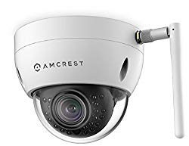
$90 from Amazon
3-Megapixel (2304 x 1296P) Dome Camera
A wide 100° viewing angle
Weatherproof IP67 housing and IK10 vandal-resistant dome
Amcrest cameras are one of our favorite brands of cameras (see the review of PoE cameras where Amcrest is our top pick for a couple of categories). Home Assistant offers to a wide range of Amcrest cameras. See more details in the integration guide

Reasons to buy
- Easy to integreate with Home Assistant
- Good quality of the picture
- Great value
- Mobile applications work really well
- Access through browser
- Long power cord

Be mindful of
- Concerns with wifi signal strength
- Poor documentation
- Cloud storage is expensive

Integration with Home Assistant
Connecting your Amcrest camera to Home Assistant is easy as Home Assistant has an Amcrest component.
Home Assistant can use built-in motion sensor and control PTZ settings. You can learn more about the integration in the component page or Python Amcrest project.
amcrest:
– host: IP_ADDRESS_CAMERA_1
username: YOUR_USERNAME
password: YOUR_PASSWORD
sensors:
– motion_detector
– sdcard
switches:
– motion_detection
– motion_recording
– host: IP_ADDRESS_CAMERA_2
username: YOUR_USERNAME
password: YOUR_PASSWORD
resolution: low
stream_source: snapshot
sensors:
– ptz_preset

Alternative Pick easy to set up camera for Home Assistant: Foscam
The majority of the Focsam camreas are easy to integrate into Home Assistant. We highlighting two cameras that worked well for the community
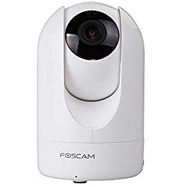
$72 from Amazon
Freestanding camera
1080P resolution 1920*1080 at 25FPS
Easy to setup
Wide angle view
Community guide
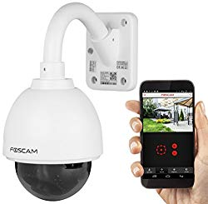
$149 from Amazon
Very good quality PTZ camera
Good integration and full controls in HA
Night vision IR light range is up to 8
3x Optical Zoom, 1280 x 960p Display Resolution, H.264 compression
Community guide

Reasons to buy
- Good lens and video quality
- Mobile applications
- Works well with other applications (Blue Iris)
- Good connection
- IR motion detection

Be mindful of
- Installation process can be overcomplicated for some models
- Not Mac friendly
- Documentation can be improved

Integration with Home Assistant
Foscam cameras work well with Home Assistant and for the majority of the cameras, it just requires a couple of lines of code in your YAML file. There are also a number of phyton scripts that you can integrate Example 1 and Example 2
https://amzn.to/2KCCSI6– platform: foscam
ip: 192.168.x.xxx
port: 88
username: username (no quotes)
password: password (no quotes)
name: Living Room

Best battery powered camera for Home Assistant: Blink Indoor Camera
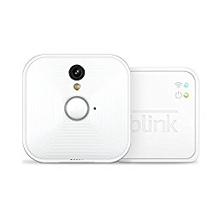
$99 from Amazon
Blink is a start-up that was founded in 2008 and was recently acquired by Amazon. It created a whole new niche of security cameras. Cameras are small but do not have the best image quality (720p). It is compensated by the fact that they are battery-operated and do not require power cables.
Blink cameras are perfect options if you want to monitor areas that are only rarely used (garden doors, entrances) or general surveillance which works when armed only. There are two main versions indoor and outdoor with the latter being possible to install outdoors.

Reasons to buy
- No cables required
- Easy to install
- Good mobile application
- Free 7,200 seconds of cloud

Be mindful of
- Battery will drain quick in crowded areas
- Always require internet – no local streaming
- Weak IR sensor
- No advanced motion detection

Camera use
Blink cameras are very easy to use. Battery lasts at least a year. When armed the camera will send the images and 90 second video clips. In disarmed mode it will be reporting temperature

Final thoughts
As you see above, there are many great video cameras that you can use with your Home Assistant. You can go DIY way tinkering Wyze Cam and get the most affordable camera for Home Assistant. Amcrest is for ease of integration.
One thing to remember is that despite integrating into Home Assistant you still should make sure the recording of your clips is sorted and also you can quickly watch.
There are a number of NVR options exists.
- Separate NVR to work – this is the most resilient and potentially comprehensive solution. See our guide on what is NVR and best NVRs around
- Shinobi Add-on for Home Assistant. Shinobi brands itself as the best open source CCTV software solution. In many ways, it is a modern version of the Zoneminder and works well with many devices.
- Install Shinobi or Zoneminder on your home server
- Use NAS as NVR. Synology 2 bay NAS DiskStation DS218+ is a great server and also has good integration option with Home assistant and NVR functionality.

